Game Analysis - Team

Evaluation of team performance

|  |  |  |  |
| --- | --- | --- | --- |
| Age Group: | □ League □ Tournament □ Cup □ Friendly | | |
| Date & Time: | | Opponent: | Location: |
| Final Score: | | First Half: | Second Half: |

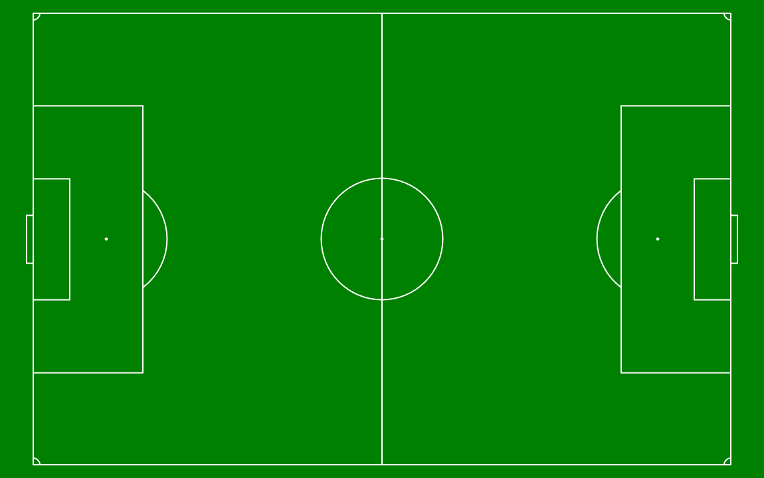

|  |
| --- |
| Indicate |
| Goals Scored (0) |
| Goals Received ( x) |

|  |  |  |  |  |  |  |  |  |  |  |
| --- | --- | --- | --- | --- | --- | --- | --- | --- | --- | --- |
| **Strengths & Weaknesses**  Scale: Poor: 1 Below average: 2 Average: 3 Good: 4 Great: 5 | | | | | | | | | | |
| Tactical | | | Technical | | Physical | | | Psychosocial | | |
| Attacking | Attacking Principles |  | Passing & Receiving |  | Strength | Strength Endurance |  | Basic | Motivation |  |
| Possession |  | Running with the ball |  | Explosive Strength |  | Self Confidence |  |
| Transition |  | Dribbling |  | Maximal Strength |  | Cooperation |  |
| Combination Play |  | Turning |  | Endurance | Aerobic Capacity |  | Decision making |  |
| Switching Play |  | Shooting |  | Aerobic Power |  | Advanced | Determination |  |
| Counter Attacking |  | Ball Control |  | Anaerobic Lactic |  | Competitiveness |  |
| Playing out from the back |  | Heading |  | Anaerobic Alactic |  | Concentration |  |
| Finishing in the final third |  | 1 vs 1 Attacking |  | Speed | Reaction |  | Commitment |  |
| Defending | Defending Principles |  | Shielding the ball |  | Acceleration |  | Self Control |  |
| Zonal Defending |  | Receiving to turn |  | Maximal Speed |  | Social | Communication |  |
| Pressing |  | Crossing and finishing |  | Speed Endurance |  | Respect & Discipline |  |
| Retreat & Recovery |  | 1 vs 1 defending |  | Acyclic Speed |  |
| Compactness |  |  | | Motor Skills | Flexibility |  |
|  | | | Coordination |  |
| Agility |  |
| Balance |  |
| Perception& awareness |  |

|  |
| --- |
| Overall rating ( 1 - 5 ): |